Horsforth Roundabout – FAILED to improve congestion but used in SAP to justify housing (mitigation) & similar schemes being ‘rolled out’ at other junctions.

It is clear to all that continuing severe CONGESTION on the A65 at the Horsforth Roundabout needs URGENT action to be taken. A flyover/tunnel may be a long term aim, but that was the case before the changes 3 years ago. Those changes, at a cost of £2.8 million, were supposed to improve congestion. No-one expected them to make it worse- as now appears to be the case. What is certainly true is that the scheme has not “relieved the current congestion on the highway network” as was claimed in 2014!

Report to Leeds City Council Exec. Board 22nd Jan 2014
“The roundabout experiences significant levels of congestion throughout the day, especially at peak periods, where queuing traffic effectively blocks the junction compounding delays. The signalisation scheme would relieve the current congestion on the highway network and improve road safety at this location. The traffic signals would also facilitate bus improvements by giving priority at the signals. The current issues at Horsforth Roundabout can be significantly improved by implementing the detailed design which has been developed by the Council’s Engineering Projects section.”
Minutes of Outer North West Community Committee, Monday, 27th November, 2017 In response to Members discussions and questions the Committee was advised of the following:- “Highways were aware that the recent improvements to Horsforth roundabout had not delivered the journey time savings that had been hoped for and work was currently ongoing to find ways of improving the situation. It was recognised that a more significant improvement scheme would be required.”
It is therefore very surprising that more apparently similar schemes costing millions are being rolled out at other road junctions before the Horsforth Scheme has been independently evaluated. The Horsforth Roundabout should be evaluated and improved BEFORE any new similar schemes are planned.
The Facts:
From 4pm onwards traffic on the A65 going towards Leeds frequently tails back beyond the Airedale Works. It then takes over 20 minutes to get through the roundabout.

Car users journeys are delayed or many try to rat run. Unfortunately one particular 'rat run' is making the Roundabout problems far worse. Instead of using the A65 many car drivers use Bayton Lane from Yeadon, then West End Lane and Hall Lane, joining the A65 near the front of the congestion queue. As the traffic is stationary this works very well for them. Even worse many then turn right towards Rodley, but as that piece of the Ring Road also has stationary traffic, the A65 is 'blocked'. This means that drivers going into Leeds are also delayed by blocking. Unfortunately the effects on Bus Services are DEVASTATING (leading to long delays & daily cancellations).
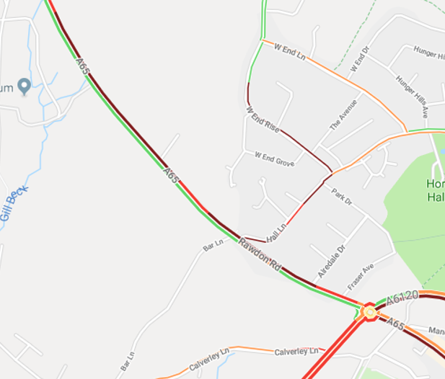
The Bayton Lane/West End Rd/Hall Lane ‘Queue Jumping’ Option: Car drivers use Bayton Lane from Yeadon, then West End Lane and Hall Lane, joining the A65 near the front of the congestion queue. As the traffic is stationary it is easy to join the A65 at the expense of the long A65 queue. ‘NO LEFT TURN’ could help solve the problem.

Journeys between Rawdon Crossroads and Horsforth that should take no more than 7 minutes are very unpredictable but can take between 5 and 30 minutes on different days from 4pm onwards. This makes the journey into Leeds take over 1 hour and can cause Airport passengers to lose connecting trains etc. It also means that buses are so late arriving into Leeds that the service back to Guiseley and Yeadon (33, 33A, 757) is often CANCELLED. Passengers have to wait up to ONE HOUR in the cold and buses are massively overcrowded - it is the rush hour!
Not surprisingly those that can abandon buses and go by car - adding to the problem. It is a downward spiral!
The effect on bus passengers in Rawdon is especially severe and has lead to new Service 19A being cut to put extra resources into Services 33 and 33A to deal with congestion.

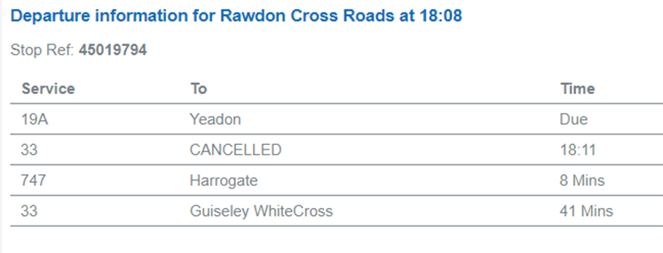
Cancelled Bus: Instead of a 3 minute wait for the 33 bus, it is now 41 mins in the cold!
NB This is a 20 minute service.

Congestion maps show clearly the severity of the problem and how the A65 queues compare with those elsewhere in North Leeds.
Congestion Map: Thursday 10th January 2018 at 1710.
NB Horsforth Roundabout from Rawdon – most congested road in Leeds? ; also Rawdon to Greengates and Headingley. NB Not the Lawnswood Arms, A61, or King Lane.

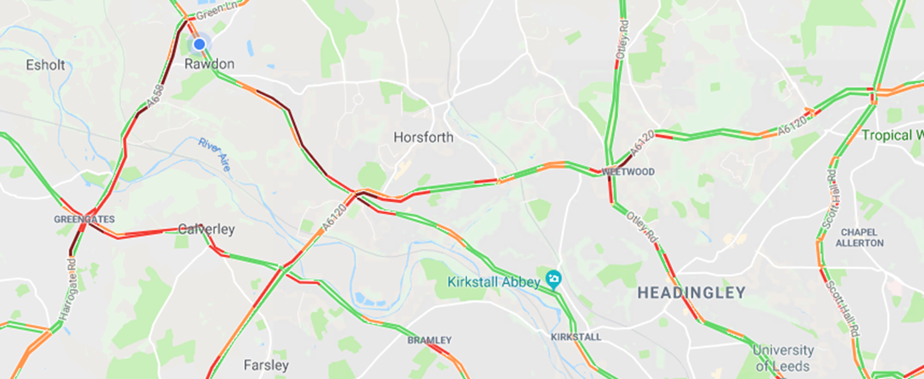
Large version of this map – see Appendix 1

We also should remember that the Rodley Roundabout was also recently 'improved', to reduce congestion, yet the traffic continues to go back to the Horsforth Roundabout.
Conclusion: Neither the Horsforth, nor Rodley Roundabout improvements have been successful at reducing congestion, despite millions of pounds expenditure. Arguably such schemes can never solve the problem of too many cars.

There clearly needs to be an independent evalutation of the A65 changes as soon as possible ESPECIALLY as Leeds appears to be committed to similar junction schemes elsewhere: Lawnswood Roundabout, A61, King Lane, Fink Hill, Dawsons Corner, and Dynley Arms. Most were already in the plans BEFORE Horsforth had been completed. On the basis of the failure of the Horsforth & Rodley Schemes it is hard to see a business case for these other schemes. It should also be noted that only a few years ago monies were spent on Dawson’s Corner and the Dyneley Arms. Were they evaluated? How do we know that the new schemes will be successful? From examining congestion maps none will make real improvements for bus services, yet Leeds claims to be doubling bus passengers in the next 10 years. The 2014 Report claimed that the traffic signals at Horsforth Roundabout would give buses priority, but that was NOT DONE.

It should also be noted that IF the new Ring Road changes do speed up Ring Road traffic, then congestion at Horsforth & Rodley will become even worse – due to the knock on effects!

It should also be noted that the Outer Ring Road has very limited public transport (bus) services and therefore any speeding up of journey times will be only for private car users – not something that public transport funds should be used for.
CANCELLED BUSES: Mon 22nd & Fri 26th Jan 2018
Metro Website: Delays to bus services, due to peak time congestion.
Severe congestion between Horsforth & Rawdon Cross Roads. Causing delays to services 33 & 33A

The Horsforth Roundabout Solution
NB 9 buses per hour in each direction operate along the A65 – compared to just 1 per hour along the Ring Road.
- Bus Service passengers will decline further unless these delays are solved – they are causing longer, and unreliable journeys for passengers, frequent cancellations and higher fares (cost of more buses and drivers to operate the bus services).
- A65 towards Leeds between Rawdon Crossroads and Horsforth Roundabout: Bus lanes from Airedale Works to vicinity of Horsforth Roundabout. This would make the bus journey reliable, quicker, stop cancellations and lead to lower fares. This could be implemented quite quickly and cheaply and would be better value for money than junction schemes.
- Hall Lane: No left turn – perhaps during am peak and 3 – 7pm, otherwise at all times. This would stop ‘queue jumping’.
- Alter traffic light timings at Horsforth Roundabout to give longer for most congested road: A65 towards Leeds. Active management of the junction using cameras.
- Rodley Roundabout: measures to avoid queue from Horsforth to Rodley Roundabout.

NB It is especially frustrating that nearly 10 years ago Aireborough Civic Society contacted WYCA (then with a different name) proposing bus lanes for the A65 and A658 to reduce congestion (Appendix 2). The suggestions were ignored.
Kirkstall Quality Bus Route
This part of the A65 is still congested at peak times, but as there are bus lanes on most of it, bus journeys are quicker than cars – making buses more attractive ( BUT ONLY if cancellations did not occur due to the Horsforth Roundabout problem!). It is salutary to think that if that scheme had been merely to spend money on road junctions ‘to speed up all traffic’ then buses would be caught up with other traffic and even more buses would be cancelled! The scheme shows the benefits of bus lanes (see photographs) and it is a mystery why it has not been implemented elsewhere on the A65.
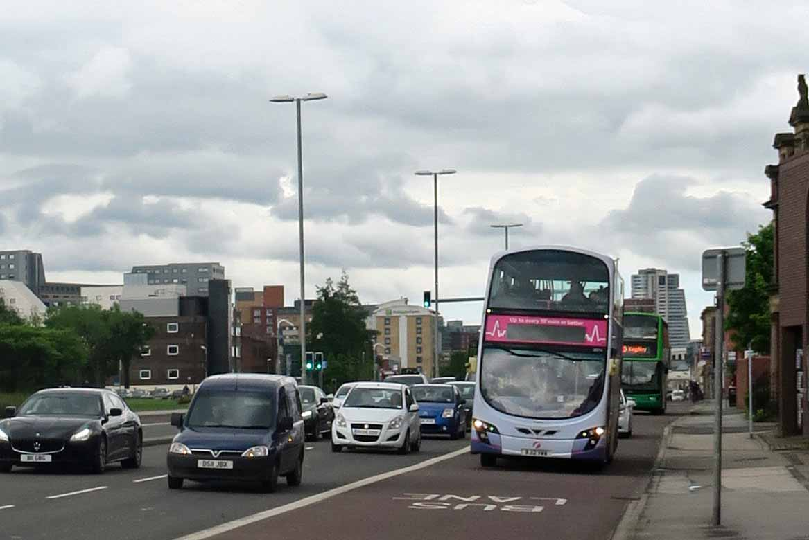
Proof that bus lanes do work!
Bus Lanes on A65 at Kirkstall ensures buses are not held up by congestion and journey times are reliable.

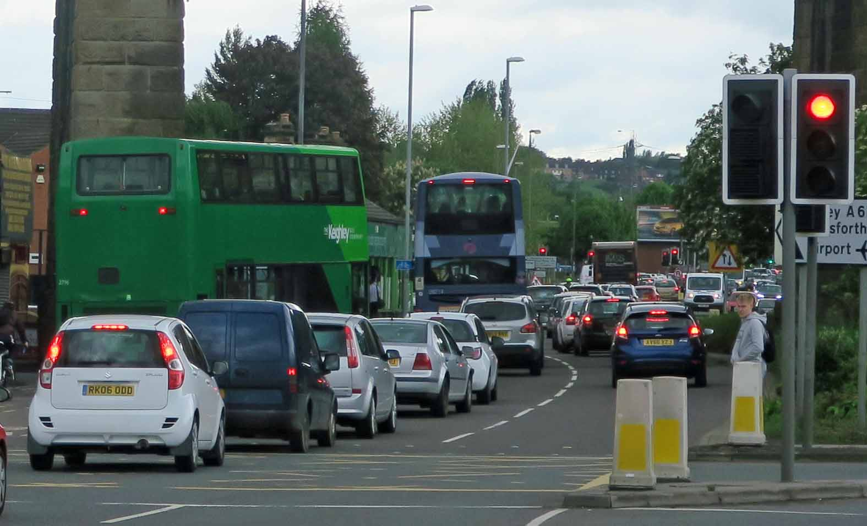
Proof that bus lanes do work!
A65 at end of bus lanes. The same buses from the previous picture then queued for over 10 minutes, here, making them late.

Leeds should be spending money on schemes similar to the Kirkstall Quality Bus Route (or cheaper schemes in Far Headingley and Chapeltown), NOT more junction schemes similar to the Horsforth & Rodley Roundabouts!

Priorities:
- Evaluate Horsforth & Rodley Roundabouts AND improve them BEFORE further changes to road junctions.
- URGENT: Improve journey times from Leeds Bus Station to Wellington St inc Headrow.
- Look at where buses are held up and look to provide bus lanes.

Clive Woods
Aireborough Civic Society/Neighbourhood Forum
March 2018

